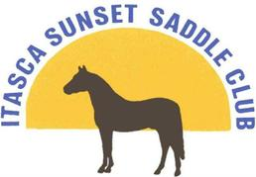Horse Show
Saturday June 1st & Sunday June 2nd , 2019
Itasca County Fairgrounds - Grand Rapids, MN
Start time is 8 a.m. Games will not start before 11 a.m.

*Highpoint Buckles Awarded for Each Age Division*
WSCA RULES APPLY 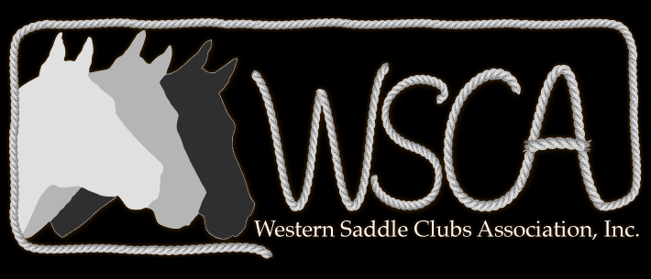
Current Negative Coggins Required
No Open Checks
4H Food booth, water & camping available
Entry Fees: $4.00 per class
Office Fee: $5.00
Highpoint Fee $10.00

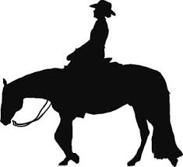
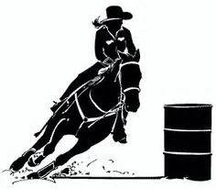

Saturday Judge: Theresa Fleener
- Open Halter
- Showmanship
- English Pleasure
- English Equitation
- Non-Stock Type Western Pleasure
- 2 & 3 Yr. Old Snaffle Bit Pleasure
- Western Pleasure
- Western Horsemanship
- Walk/Trot
- Lead Line – 6 & under
- Bareback
- Egg & Spoon
- Pole Weaving
- Key Race
- Barrels
- Jumping Figure 8
- Speed Dash

Sunday Judge: Joy Ratkowski
- Open Halter
- Showmanship
- English Pleasure
- English Equitation
- Non-Stock Type Western Pleasure
- 2 & 3 Yr. Old Snaffle Bit Pleasure
- Western Pleasure
- Western Horsemanship
- Walk/Trot
- Lead Line – 6 & under
- Tandem Bareback
- Egg & Spoon
- Pole Weaving
- Key Race
- Barrels
- Open Ribbon Race

Stall and camping: Information Marge 218-327-0317
Check out our club at www.isscmn.net
Or find us on Facebook

All classes broken down by WSCA age groups unless specified.
****************************
PW, JR, INT, SR, SR+, SR++

